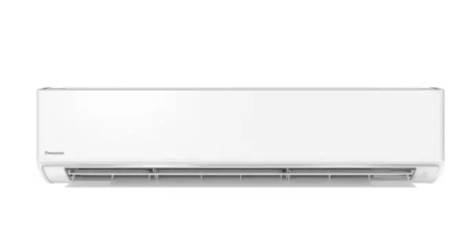
Panasonic split air conditioner
Rs.165,000
Panasonic split air conditioner CS-PS13UKF is a 1.5 ton inverter model with Eco Cool performance, R-32 refrigerant, and quiet room comfort.

Specifications
- Model: CS-PS13UKF
- Capacity: 1.5 Ton
- Cooling: 18,000 BTU/hr
- Refrigerant: R-32

Key Features
- Panasonic inverter
- Turbo cooling
- Blue fin condenser
- Whisper-quiet operation

